Notes and Chat from the Suffolk Information Partnership meeting
Thursday 20 January 2022, held on Microsoft Teams

- Welcome, introductions and housekeeping – Kate Turner

See below for introductions and contact details of partner organisations.

- Warm Handover referrals update– Kate Turner

Statistics

Warm handover stats for 2021:
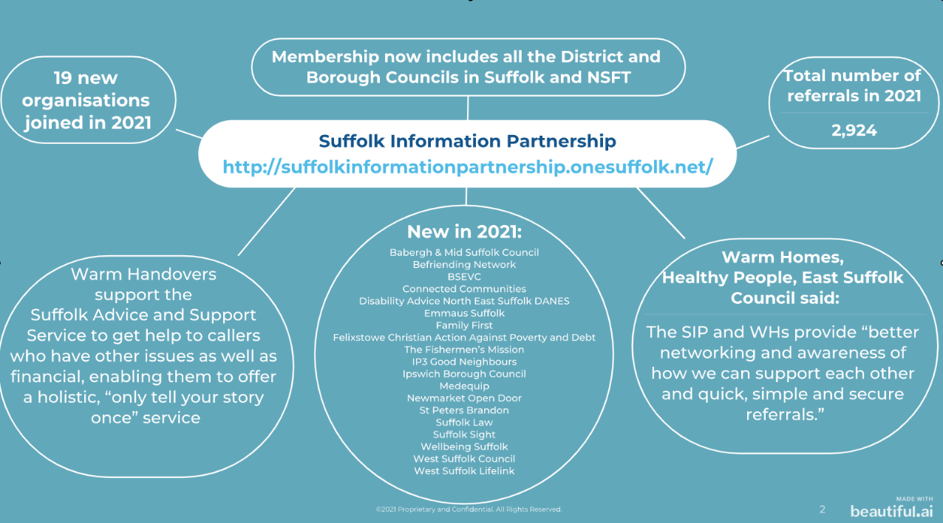

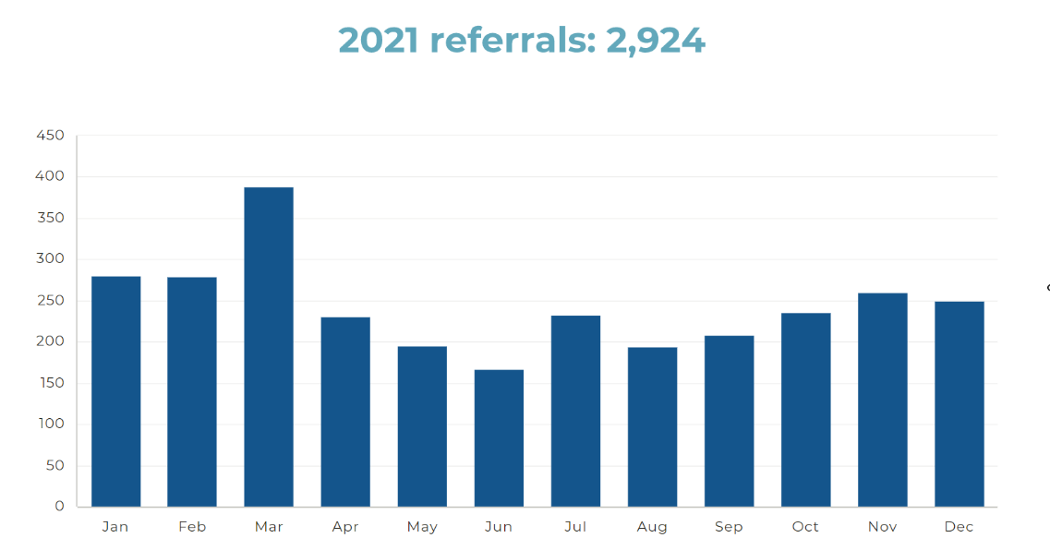

If you would like details of the number of referrals you have sent and received for your managers or annual report please let Kate know, with the date range you want the stats to cover.

Training and support

In December Kate moved from Adult Social Care to Public Health at the County Council and is now working on SIP full time (30 hours a week, with Mondays off).

The one hour, monthly training sessions have been well attended and are an opportunity for all staff in your organisation to find out about the SIP and Warm Handover and meet those from other organisations.

The dates for 2022 so far are:
  - 15 February – nearly full
  - 17 March
  - 6 April
All sessions are held virtually on Microsoft Teams. Go to the SIP website and follow the link to Eventbrite to book. A link to the Teams session will be sent about a week before.

In a discussion on other support that would be useful Jayne Green from Contact & Trace expressed a need for help with languages and translation services. These comments were received:

- Emma Joy-Staines “we have also had a few translation needs recently just last 8 months really started happening regularly - we rely on our community members who volunteer their time”
- Kimberly Roberts (Mid Suffolk CAB) “Our network uses Language Line https://www.languageline.com/uk/s/”
- Emma Joy-Staines to Jayne Green “what languages are coming up for you? we have had mainly eastern translation requests Urdu, Pashto etc”
- Jayne Green to Emma Joy-Staines “we have mainly Eastern European queries”
- Sue Wardell (Suffolk Law Centre) “Clear Voice offer interpreting and translation services. We use them for appointments. Clear Voice Interpreting Services, telephone & video interpreting, face-to-face interpreting, and translation services that break down communication barriers”
- Abigail Morris “LifeLink also uses Language line and it works very well.”
- Sarah Stapleton “I think Language Line is quite expensive?”
- Richard Moore “google translate is a free app which does the same as what Alison spoke of with voice functionality, i'm unsure of the accuracy but is probably worth trying”
- Vicky King “BME resources BME resources (ipswichandeastsuffolkccg.nhs.uk). There are some groups on here and a couple of links for translation services”

Kate reminded the group that if there is someone in your organisation who speaks a language and is willing to offer informal support to add them to the What partner’s do spreadsheet.

Keeping your details up to date

Kate reminded the group to check their information on the SIP website and update their details by using the link “Update your information on the spreadsheet here” or notifying Kate if your logo or information on the Partners page needs changing. Also remember to update your Suffolk InfoLink record too.

Payments

Kate is working on the October - December 2021 payments and apologies for the delay. For those organisations eligible for payments this quarter you will receive an email with the amount owed to you. The money will be automatically credited to your bank account and the amount is still £20 per referral.

Newsletter

The last newsletter was in September 2021 so the group was asked if they would like another one for the spring. There was agreement that this would be useful.

Action: Kate to organise the collection of submissions

New referral form update

Changes in staffing and priorities within Suffolk County Council’s IT department, who host the existing and new platforms for the referral form, means that the new SIP form has been delayed. They are working on how organisations will pick up their referrals and no date has been given for go live. Therefore, Kate has agreed with them that they will make some minor changes to the wording on the existing form, such as changing “person with care needs” to “client”. Kate will let you know when these have been made.

- Meeting New Partners

Suffolk Constabulary - Rob Meen, Sergeant – East Neighbourhood Partnership Team
robert.meen@suffolk.pnn.police.uk

Rob has a wide remit. The Neighbourhood & Partnership team covers school liaison, young persons, youth offenders, modern day slavery, missing persons, digital crime, rural crime.
Crime prevention is our main service, e.g. home security, fraud, e-scooters etc. You can use the Warm Handover to make referrals to crime prevention by choosing “Police Crime Prevention” on the referral form. Please note though that reporting victims of crime or anyone at risk of harm must go through the traditional means of phoning 999, in an emergency, or 101.

Recently joined organisations

Steel Bones – Emma Joy-Staines emma@steelbone.co.uk

We help amputee family members link up with amputee volunteers to provide lived experience support including linking up with sports, hobbies, etc to help to build confidence. We work across the UK but are based in Suffolk.

Inside Out – www.insideoutcommunity.com marie@insideoutcommunity.com 01473 563900

Janine and Marie are part of a community of artists where the power of art helps maintain mental wellbeing. Groups run for under 25’s, over 60’s etc. and are free, covering Ipswich and surrounding areas. Their virtual groups cover countywide. There is no waiting list so please get in touch.

Marie added in the chat: “Inside Out Community is a charity providing artistic workshops for emotional wellbeing and mental health. Based in our new venue at Gatacre Rd, Ipswich, we offer a range of visual arts, music, dance and creative writing. Currently, we have spaces available for artistic activities for young people (18-25) in our Mon group 2-4pm and people over 65 on Wed 2-4pm. All sessions are free, no referral needed.”

Befriending Network – Laura Cox-Watson laura@thevoluntarynetwork.org

We provide companionship to people across West Suffolk only aged 60 plus. Since May 2021 face to face befriending is back and they are happy to receive referrals for bereavement, low mood, anxiety and dementia light touch companionship. Sometimes the friendships last for years!

Family First – Sarah Stapleton sarah.stapleton@familyfirst-uk.org

We cover Ipswich and very local surrounds and offer a volunteer mentoring service including parent mentors helping families thrive and be happy. Volunteers visit for an hour a week providing an empowerment based service. Our website www.familyfirst-uk.org gives more information about what we do and has some testimonies from families we have supported.

Emmaus Suffolk – Emma community@emmaussuffolk.org.uk

We help the homeless in Ipswich and Felixstowe areas and provide community hubs, drop-ins, arts and crafts, chess, colouring, etc. We help the socially isolated and provide opportunities to gain gardening and upcycling experience. Look at our Facebook page for more details. We also provide a small housing offer, which we are hoping to expand.

From the Chat:
- Marie Grueberova, Inside Out Community “Hello Emma, sorry, I didn't catch the name of your charity, (homelessness, Ipswich and Felixstowe Community hubs) could you please share your email. We have some funding for outreach artistic workshops in Fxt. We could have a chat. My email is marie@insideoutcommunity.com. Thank you. Marie”

Sharing Parenting – Ginny info@sharingparenting.com www.sharingparenting.com

Sharing Parenting is a Community Interest Company, based in Newmarket since 2009, working in partnership with parents, carers, schools, Children’s Centres and community groups in Suffolk, delivering parenting support in the form of courses, workshops, taster sessions, one to one support and community pop up’s for parents to gain confidence and knowledge in their role as parents, or professionals supporting parents, in a non-judgemental environment. We believe that good quality, reliable parenting information and support should be available to all parents and professionals.

We have programmes for parents lasting 10 weeks, which are free for parents and carers to improve confidence supporting their children and helping parents back into education/training/work. Contact hannah@sharingparenting.com

A new Community Ambitions Project is open to all families but especially where English is a second language. www.sharingparenting.com/for-parents/where-to-meet-us/community-ambitions-newmarket-bilingual-parents-group/

They also support parents who have children with Special Education Needs.

Discussion:
- Sarah Stapleton - “we are seeing a real rise in referrals for families with children either with a diagnosis or waiting for one. I would say at least 75% of referrals now. I may well be getting in touch after this!”

- Ginny from Sharing Parenting - Sarah, that would be great. you can contact Clare at Clare@sharingparenting.com

- Alison - I would agree Sarah, at Home-Start in Suffolk we have seen a 21% increase in Self referrals and most of these are for children with additional needs and being assessed at present.

Medequip – Paul Randall Paul.Randall@medequip-uk.com

We offer a full response service, taking pressure off the ambulance service, and provide watches, GPS tracking, GO device which pinpoints your location if you fall, etc. We are switching our devices over to digital from analogue and work in partnership with the Fire Service linking up smoke detectors to alarms.

From the chat:
- Jayne Green “could I have an email address for either you or your service please I've got a very complex and disabled elderly man who would benefit from your services”
- Paul Randall Hi Jayne, paul.randall@medequip-uk.com “im sure we can help”

- Brief Service Updates

Family Hubs

The Warm Handovers referral is a key tool in the Suffolk County Council Family Hubs model, where its use will be piloted in the Central Suffolk area, linking children and families to community support and other professional help such as benefits checks from Citizen’s Advice. The plan is to eventually roll the Warm Handover out to all family hubs across the county.

The Family Hubs model builds on the existing Children’s Centres, extending provision from 0-5 to 0-18, and 25 for Special Educational Needs and offering a location for children, young people and parents / carers to find health services, parenting support and community activities.

Linking adult social care and Good Neighbours

A pilot started in mid-January between East Ipswich Integrated Neighbourhood Team (INT - made up of adult social care and community health staff) and the IP3 Good Neighbours, where IP3 receive a Warm Handover referral and use their volunteers to provide a range of practical support to a person visited by one of the INT to do a care assessment or provide nursing care. This could be anything from emergency shopping to befriending.

Early feedback shows very positive results and relationship building, and Kate plans to work with Community Action Suffolk to encourage other Good Neighbour networks with a similar approach.

Your News

- Leiston Citizens Advice - we have an adviser who has an IT background and so we are now offering clients IT help (showing them how to upload documents, log on to systems, use chat functions, etc.)
Chiara, bureau@leistoncab.cabnet.org.uk

- Customer First – the Social Care Call Centre, are recruiting and offering permanent and temporary roles. Recruitment at this current time is challenging, the market is competitive and we’re looking for a particular skill set/passion for our line of work. If you have anyone in your wider networks interested in a career with Customer First/Social care (it’s a great position for further progression), please. The best way to discuss routes into working for us is via the email address on the advert:

- Connected Communities update January 2022 - We are now out and about more in the communities in East Suffolk, and you may be wondering what we can offer? Do you know someone over 65 who could do with a little help? Are you over 65 but unsure if our services are right for you?
We can meet with you and really get to know you and what matters to you. We can then use our local knowledge to support you in finding opportunities to solve any issues you have. If this is the case please get in touch for an informal chat. Simply contact us at:
Suffolk Family Carers on 01473 835477 or email connectedcommunities@suffolkfamilycarers.org
You can also have a look at our latest newsletter to see where we will be in East Suffolk in the upcoming months.

- Felixstowe CAP - are offering a new course called Life Skills – helping people to live on a low income, which starts on 11 February. They can also be found at pop up shops in Felixstowe.
- Sarah Stapleton “We refer to CAP a lot Steve - fantastic courses.”
- Steve Lineham “for info on the Life Skills course or mentoring on money issues please contact me Steve - steve.lineham@btinternet.com”

- Warm Homes Healthy People – “With our current funding we can offer support with External Wall and Cavity Wall insulation, Loft, flat roof and room in roof Insulation, Draught proofing, Emergency loan heaters, Solar PV systems and some Air Source Heat Pumps. Also, with our Winter Hardship Fund for households without children under 19 we can fund heating repairs up to £500, 7 days of meals (cooked meal delivered and food parcel) and winter warmth packs. We can offer a Warm Homes Survey where a surveyor can look to see what measures would help to improve the energy efficiency of their properties as well as provide support and advice with their energy bills etc. Unfortunately, we are not able to fund first time central heating or replacement boilers anymore.”
Paula Crisp, paula.crisp@eastsuffolk.gov.uk

- Mid Suffolk Citizens Advice - provide an Energy Advice Programme, helping people with energy debt and advice.
We also offer training/information sessions to frontline workers of other organisations to explain what they can refer to Citizens Advice for. Email Kimberly Roberts at operations@midsuffolkcab.org.uk

- West Suffolk Citizens Advice – have seen a huge rise in people asking for help with energy bills. They are offering advice on grants and can also provide carbon monoxide monitors.
Sarah Bradbury, sarah.bradbury@swcab.org.uk

Question asked: “Should we give out the Citizens advice number or use the referral form?”
Sarah replied: “As people usually have so much going on they may not make the call so better to use the referral form.”

- Suffolk Sight - We work with people with sight loss and visual impairment. Feel free to contact me directly if you have any questions about our service, Jade Rowlinson j.rowlinson@suffolksight.org.uk

- West Suffolk Council LifeLink - We work across West Suffolk linking in with the Primary Care networks. The areas we cover are: Haverhill, Sudbury, Sudbury Rural, Bury Town, Bury Rural, Brandon, Mildenhall and Newmarket. LifeLink (westsuffolk.gov.uk) LifeLink connects people to social activities, clubs, groups and local services that are on offer in their local community.” Abi Morris, Social Prescriber

- ACS Independence and Wellbeing Service - Just here to see if there are any local resources that we can use with our adult service users.” Vicky King

- Suffolk Carers Matter at BSEVC - (our CEO Jo Reeder is also on this meeting!) Our contact number at Suffolk Carers Matter is 01284 333035, but we are based at Red Gables in Stowmarket.” Vicki Lee

- BSEVC - Charity based in Stowmarket with three core services - Community Transport (Ipswich & Mid Suffolk), Suffolk Carers Matter (family carer support service, countywide) and Later Life Community (65+ service, countywide) - www.bsevc.co.uk Jo Reeder

- Suffolk Law Centre - We provide free legal advice in civil and welfare law. We are one of the new organisations joining this year and we've found it really useful to be part of the SIP network. For avoidance of confusion - we are added in the slide showing the stats as 'Suffolk Law' so please add the missing 'Centre' when you can! If you have any questions re: Suffolk Law Centre, please get in touch with me, Sue Wardell”, Sue@suffolklawcentre.org.uk

- Suffolk Libraries - Kellie Dimmock is the Information for Living Librarian from Suffolk Libraries. I work across all our 44 libraries and soon to be opening no 45 (Morton Hall in Bury.) I work with charities and organisations on information training and support with partners like CA - Kimberley, Sam - at BMSDC, Jo at BSEVC, supporting customers and staff in areas such as employment, Universal Credit, health, e.g. cancer information, subscription services on our website www.suffolklibraries.co.uk/reference-library, environmental sustainability, dementia / Parkinson's , accessibility and diversity, and if it's not my area I can find out a person who can!

- Groundwork - “It's my first SIP meeting and if you're interested in finding out more about Groundwork we're at East of England - Groundwork and my email address is kerry.stranix@groundwork.org.uk. I'm really happy to talk one to one about our activities, which are focused on community and environmental projects like community gardens and growing, training and skills, outdoor family activities and energy advice. Groundwork is working across the East of England to create stronger, healthier communities, responsible business and greater prospects for local people.” Kerry Stranix

- Short Break

- Digital Care - what is it, how you can refer and who to - Jemma Mindham and Anita Millar, Rethink Partners

Jemma and Anita gave a presentation on digital care and the products available as part of the Cassius offer. Their slides will be circulated with these notes. The meeting then divided into breakout rooms to discuss case studies and appropriate devices that could support in that situation.

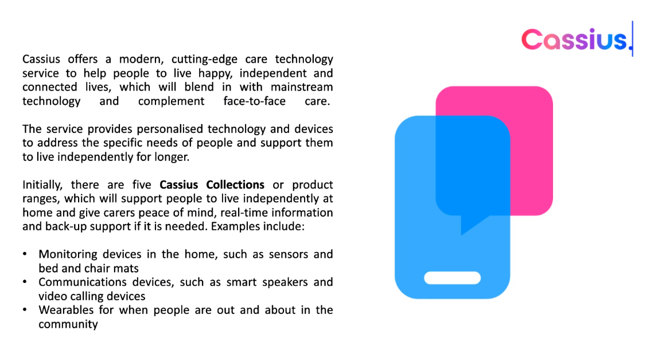
For any clients who may be eligible for social care support and funding, under the Care Act 2014, you can refer to Customer First on the Warm Handover Referral form and add digital care as the reason for the referral. Alcove, the equipment supplier, is also looking at an offer for self-referrals and fee paying customers.

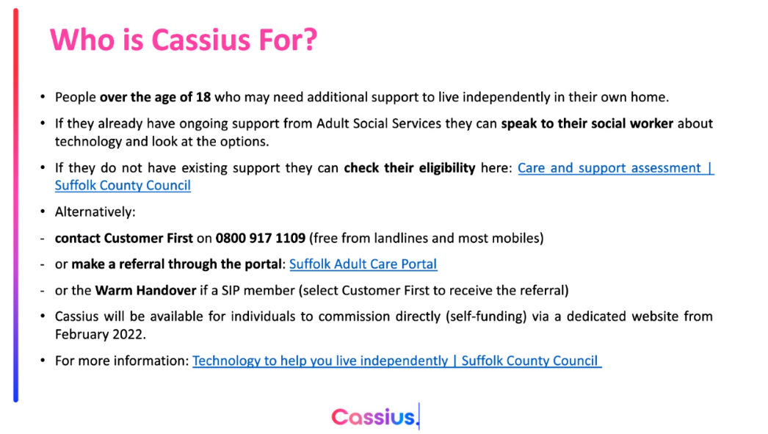

- Any other business

Suggestions for future meetings / collaborative working

- Partners to recommend new organisations to fill gaps in services
- Break out rooms with partners from your geographical location

- Dates and venues for next meetings

- Thursday 28 April 2022, 10am – 12pm on Microsoft Teams
- Thursday 14 July 2022, 10am – 12pm on Microsoft Teams

Melanie Bardella / Kate Turner
Suffolk County Council
February 2022

