Notes from the Suffolk Information Partnership meeting
held on Thursday 14 July 2022 on Microsoft Teams

- Welcome, introductions and housekeeping
See below for partners’ contact details posted in the meeting chat.

- Warm Handover referrals update
Public Health and Communities reorganisation
As of this week Kate is now officially Warm Handover Manager managing the SIP and Warm Handover process following a reorganisation in the Public Health and Communities Directorate. This means she is working full time for the Partnership (Tuesday – Friday).

SIP website “What partners do” page
As discussed at the last meeting Kate and the InfoLink Team have been working on expanding the number of topics on http://suffolkinformationpartnership.onesuffolk.net/partners/what-partners-do/ to bring the page in line with the spreadsheet. This will provide another tool to support partners with signposting and finding the most appropriate organisation to make a referral to. A list of topic labels were discussed and suggested:
- Consumer rights and advice
- Equality and diversity
- Health and care – sub heading Social prescribing
- Older support / support for older people
- Young people
Kate to circulate the list of topics with these notes for further suggestions. Work will take place over the summer to add new buttons to the What partners do page and link the topics to partners’ Suffolk InfoLink records. The SIP InfoLink records will be deleted.

Training sessions
New dates for the autumn are now available to book on the events page of the SIP website, with the first session on 7 September. The sessions are online, last one hour and are suitable for new staff and organisations to familiarise yourselves with how to make a referral. They also provide an opportunity to meet partner organisations.

Stats
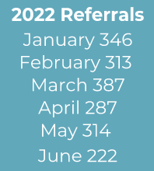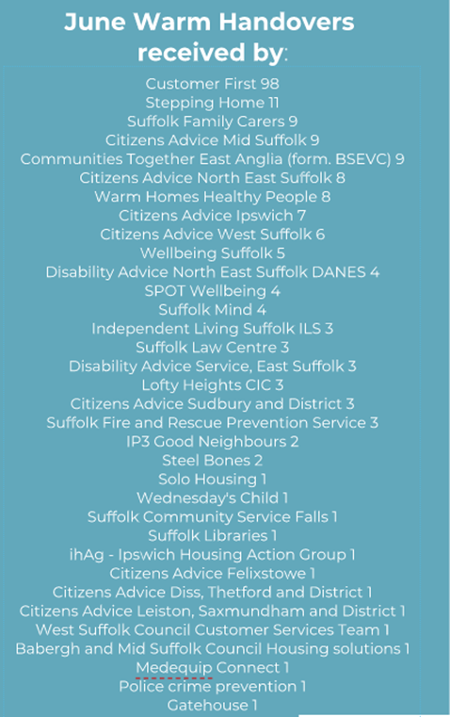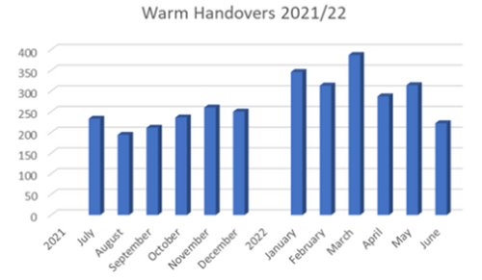
The number of referrals made in June is significantly down on previous months. Suggestions for this were: entering the summer months, bank and school holidays at the beginning of June and, probably more significantly, changes to commissioned organisations delivering services, such as advocacy and dementia. Kate has contacted the new providers with little success so far.
Vicki Lee: “PowHer, Alzheimer's (Dementia Connect), NSFT - these are the 3 services that it would be good to see on the SIP and undoubtedly increase referral numbers...”

Suggestions were made on how to promote the SIP and Warm Handover to staff and raise its profile:
  - Rob - “It’s difficult to keep SIP in forefront. Need posters with QR code”, to put up in offices
  - Nicola - “Could we have a banner to add to signatures?”
  - Use SIP funds to create promotional materials
  - Circulate Warm Handover stats every month
  - Promote training sessions to all staff

Kimberly asked for more management information, e.g. referral progress and outcome. The current system does not provide this, but Kate can provide your organisation with the number of referrals made and received and to which / from which organisation.

Payments
Kate is working on the April – June payments and will notify eligible partners of the amount due.

This will be the last quarter that payments will be made for referrals sent and received. Public Health and Communities have agreed to make payments from 1 July 2022 – 31 March 2023 but only to organisations receiving referrals. The amount will still be £20 per referral.

CAS Healthcheck
As more organisations are joining the SIP Kate has been working with the Training, Safeguarding and Quality Standards Development Officer at Community Action Suffolk on developing a set of quality standards suitable for SIP partners. These will include data protection, which is a current SIP requirement, and also safeguarding and other governance areas. The tool will be a self-assessment checklist and will ensure that referral partners are trusted and well run organisations. More information at the meeting in October.

Newsletter
The group agreed that it would be helpful to have a newsletter in September. Kate to collate news and updates.

Case studies
Please send anonymised case studies where you have used the Warm Handover so they can be shared and used to promote our impact, e.g. with payment funders.

New partners and updates

New partner organisations since the last meeting:
- Progression Sessions Progression Sessions | A self-directed group for disabled young people moving into adult services (wordpress.com)
- Walton Parish Nursing Walton Parish Nursing - Home Page (waltonpn.org.uk)
- Green Light Trust Green Light Trust
- Wednesday's Child Supporting Eating Disorder Recovery – Wednesday's Child (wednesdayschild.co.uk)
- Solo Housing About Solo Housing – Solo Housing
- ActivLives Get Everyday Activ in Suffolk | Motivating, supporting and inspiring healthier lifestyles (activlives.org.uk)

Partner updates:
- BSEVC – has changed it name to Communities Together (East Anglia) comprising Suffolk Carers Matter, Later Life Community and community transport. The referral form and SIP website have been updated with the new name.
Jo Reeder, CEO, provided this update:
Communities Together East Anglia (formerly BSEVC) is continuing to broaden their support available to people within communities across Suffolk – with a focus on community transport (Ipswich & Mid Suffolk), family carer support through Suffolk Carers Matter (countywide) and Later Life Community (countywide).
Under the Later Life service, CTEA has just launched a countywide befriending service – BeAFriend, which will work primarily with people aged 65+, encouraging community and social integration through telephone, digital, pen pal or face to face support at a hyper-community level.
The service will take referrals from anywhere in the county (including border towns) and will seek the most appropriate source of support for the individual – for example, if there is already a befriending programme available in the area, we would initially refer to said organisation to see if they can support – with the premise that the more local the support, the better outcomes for the beneficiary.

- Citizens Advice North East Suffolk, Leiston, Saxmundham and District and Felixstowe have amalgamated to form Citizens Advice East Suffolk. The new organisation is working through its governance and process arrangements and when ready this will be updated on the SIP website and referral form. More information to follow.

Any Other Business

Suffolk InfoLink has been relaunched. Deborah Sage gave a presentation at the April meeting to say changes were coming and here is her update. Please compete the survey.
As you’ll recall from our presentation to the Partnership a little while ago, this work has been in the pipeline for some time – it’s been 7 years since the last real development of the site, so is much overdue.
As a reminder, and for those who missed the presentation, our digital platform hosts over 7,000 local records, providing a rich directory of services and organisations which support Suffolk communities.
The website has been operational for 34 years, originally available through a small number of Suffolk libraries, but has since grown to become one of the largest community directories in Suffolk. I’d encourage you to take a look at the live site www.suffolk.gov.uk/infolink and provide your feedback to the team through the survey found near the top of each page.
The work has updated the look and feel of the site and brought it up to standard for accessibility. There is further work to happen in the future, so this is just the beginning of the development, and thank you for the suggestions and comments made since the SIP meeting.
Please do share the website link with partners and colleagues, as the website is only as good as the information local organisations and groups add to it, and keeping its profile high is key to encouraging its use.
Should you have any questions relating to the site, please contact the Community Information Team at infolink@suffolk.gov.uk

- Networking sessions
The rest of the meeting consisted of three breakout sessions where partners met in smaller groups to introduce themselves, swop contact details and discuss common issues. The first two sessions were by geographical area and the third session was by subject, bringing organisations together who provide services in a similar field.

The technical capabilities of Microsoft Teams did not allow for consecutive sessions to be set up in advance so apologies to some of the group whose journey into the breakout rooms did not go as smoothly as it should have done.

- Feedback and summing up
Despite the technical difficulties everyone enjoyed the sessions and found them beneficial in making new contacts and discussing collaborative working.
There was a suggestion to stay in touch outside the quarterly meetings and have a contact name for each organisation to discuss anything arising. All were happy for Kate to circulate the SIP mailing list on the proviso that it would be for the SIP contact only and should not be shared with other staff or names given to the public.
The group also welcomed the suggestion to have a networking session at the end of each meeting, themed by geographical area or topic. The first one will be by topic at the October meeting.

- Dates and venues for next meetings
10am – 12pm Thursday 20 October 2022, Microsoft Teams

Recent survey results showed that most partners preferred online meetings rather than face to face. Suggestions were also made on future agenda items. Kate will look into these.

Melanie Bardella / Kate Turner
Suffolk County council
July 2022

